Capabilities covered:
- Use C# Programming to implement business layer of your application
- Test, and Debug your application to make application ready for deployment

Assignment 1: Exception Handling
Estimated time: 50 minutes

- In the created User class, the data members are
  - userId : long
  - dateOfBirth : String
  - fullName : String
  - gender : String
  - emailId : String
  - password : String

Write User Defined Exceptions to handle the following:

When creating a new user the
- If the length of userId is less than 5 chars then give out an InvalidUserIdException
- If the password do not contain numbers or is not a combination of capital or small case chars or if the length is less than 5 chars then give out an InvalidPasswordException
Create the following methods for class UserManager implement these new restrictions
- createUser(User user)
- showUserDetails(User user)

Assignment 2: Exception Handling
Estimated time: 40 minutes
Create the Class UserConsole with the following methods

public User acceptUserDetails()
public void showUserDetails()
public void printMessage(String message)
These methods can use Console.ReadLine to accept details of the new user.
Modify the methods in the class UserManager to call the methods of class UserConsole .
The UserManager class has already implemented the restrictions on loginId and password. But now if the loginId or the password entered by the user violates restrictions then he must communicate to the UserConsole who in turn will let the User know.
If the user has entered all the details correctly then the UserConsole class can use the printMessage() to print a Welcome message to the user.

Assignment 3: ArrayList
Estimated time: 1 hour
Create Business classes for the following
Create a class BankManager, having list of accounts.
- public boolean createAccount(Account account)
- public Account getAccountById(int accountNo)
- public List getAllAccounts()

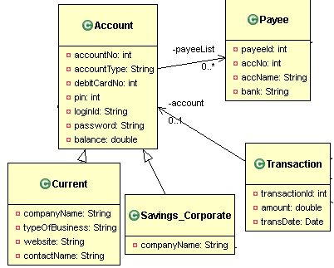

Assignment 4: Unit Test using MSTest framework
Estimated time: 50 minutes
- Create a Unit Test for validating the functionality of the UserManager Class.

- Create Unit Test for validating the AccountManager Class. Please refer to the Assignment 3.

